

**ssp workshop**

CASE STUDY: Pavitra Ganga Pilot

**participant’s worksheets**

SSP Workshop

Participant's Worksheets: **Pavitra Ganga Pilot**

**Contents**

Worksheet 1: Module 2.1 – Map the system 1

Flow Diagram 1: Jajmau STP and Village 2

Flow Diagram 2: CW+ and IPC and Village 3

Worksheet 2: Modules 3.1-3.4 (simplified) 4

Table: Hazard/risk assessment table 5

Semi-quantitative risk assessment Tools 3.3 and 3.4 7

The Potential Impact of Using the Pavitra Ganga Novel Technology in this System 8

Worksheet 3: Module 4 (simplified) 9

Table: Proposed control measures (simplified version) 9

Worksheet 4: Module 5 (simplified) 10

Table: Operational monitoring plan (simplified version) 10

Worksheet 5: Module 5 (continued) 11

Table: Verification monitoring plan (simplified version) 11

# Worksheet 1: Module 2.1 – Map the system

**Introduction:** This worksheet activity is to get you started on the system description of the Pavitra Ganga project. Map the system from the influent to Jajmau STP to the use of the effluent by the farmers in the village. Use the components preliminary treatment, primary treatment, secondary treatment for the STP (see Case Study). Then map the system with the novel technology (remember this is secondary treatment step).

**Task:** Map the two systems using a flow diagram. Identify *all* waste streams (inputs and outputs) and those exposed. You can first sketch the flow diagram on your worksheets.

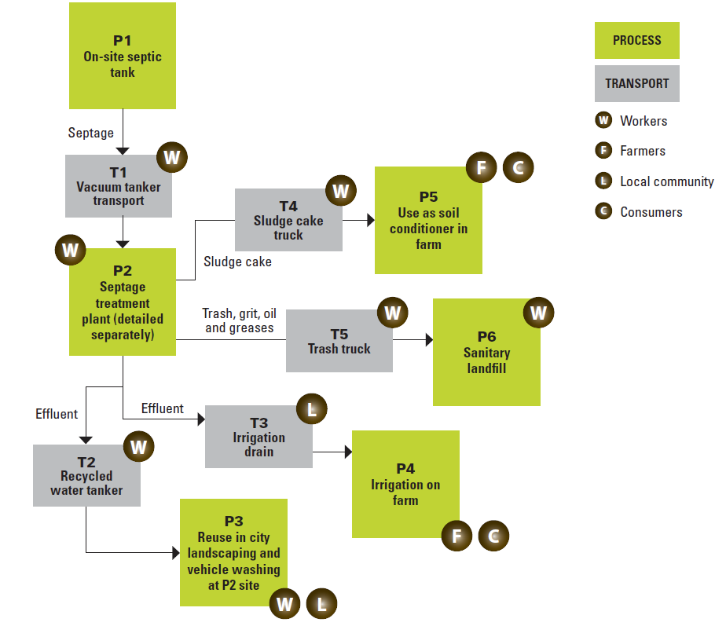**This should take you approximately 30 minutes.**

* **Examples see SSP manual Guidance Note 2.1 & Examples 2.1 – 2.3 & Newtown SSP pages 95-100.**

# Flow Diagram 1: Jajmau STP and Village

# Flow Diagram 2: CW+ and IPC and Village

# Worksheet 2: Modules 3.1-3.4 (simplified)

**Introduction:** Module 3 of the SSP process has the ultimate objective to produce a prioritized list of hazardous events to guide system improvement.

**Task:** Use the 'hazard/risk table' on the next page for completing this worksheet activity (🡪 example of a completed hazard/risk table see SSP manual pages 105-110). Then follow these steps:

1. Identify one hazardous event (Col B1), one potential associated hazard (Col B2; consider: biological hazardous only) and exposure group (s) (Col B3) for the system component identified in Col A1.
2. Under the assumptions that no control measures are in place yet, conduct the risk assessment (Col D1 to D4) for each of the hazards and exposure routes you have defined in the previous step. For this apply the Tools 3.3 and 3.4 of the SSP manual (🡪 see page 7 of the participant's worksheets).
3. Review the potential impact of implementing the novel Pavitra Ganga technology fill in the box in page 8.

**This should take you approximately 30 minutes.**

## Table: Hazard/risk assessment table

| **Col A1, A2** | | **Col B1 to B4** | | | | **Col C1 to C2** | | **Col D1 to D4** | | | |
| --- | --- | --- | --- | --- | --- | --- | --- | --- | --- | --- | --- |
| **Sanitation step** | | **Hazard Identification** | | | | **Existing Control(s)** | | **RISK ASSESSMENT** | | | |
| L=Likelihood; S=Severity; R=Risk level (e.g. High) | | | |
| **Col A1**  **System component** | **Col A2**  **Process step** | **Col B1**  **Hazardous event** | **Col B2**  **Hazards** | **Col B3**  **Exposure route(s)** | **Col B4**  **Exposure Group(s)** | **Col C1**  **Description of existing control** | **Col C2**  **Validation of control** | **L** | **S** | **Score** (L x S) | **Risk rating** |
| **□ Waste treatment** | **Current secondary treatement at Jajmau** |  | Biological |  |  | None in place | N. a. |  |  |  |  |
| **Novel Pavitra Ganga seconday treatment** |  | Biogolcial |  |  | None in place | N. a. |  |  |  |  |
| **□ Re-use** | **Farmers irrigation using the effluent from Jajmau STP** |  | Biological |  |  | None in place | N. a. |  |  |  |  |
|  | **Farmers irrigation using the effluent from the Pavitra Ganga novel treatment** |  | Biological |  |  |  |  |  |  |  |  |

## Semi-quantitative risk assessment Tools 3.3 and 3.4

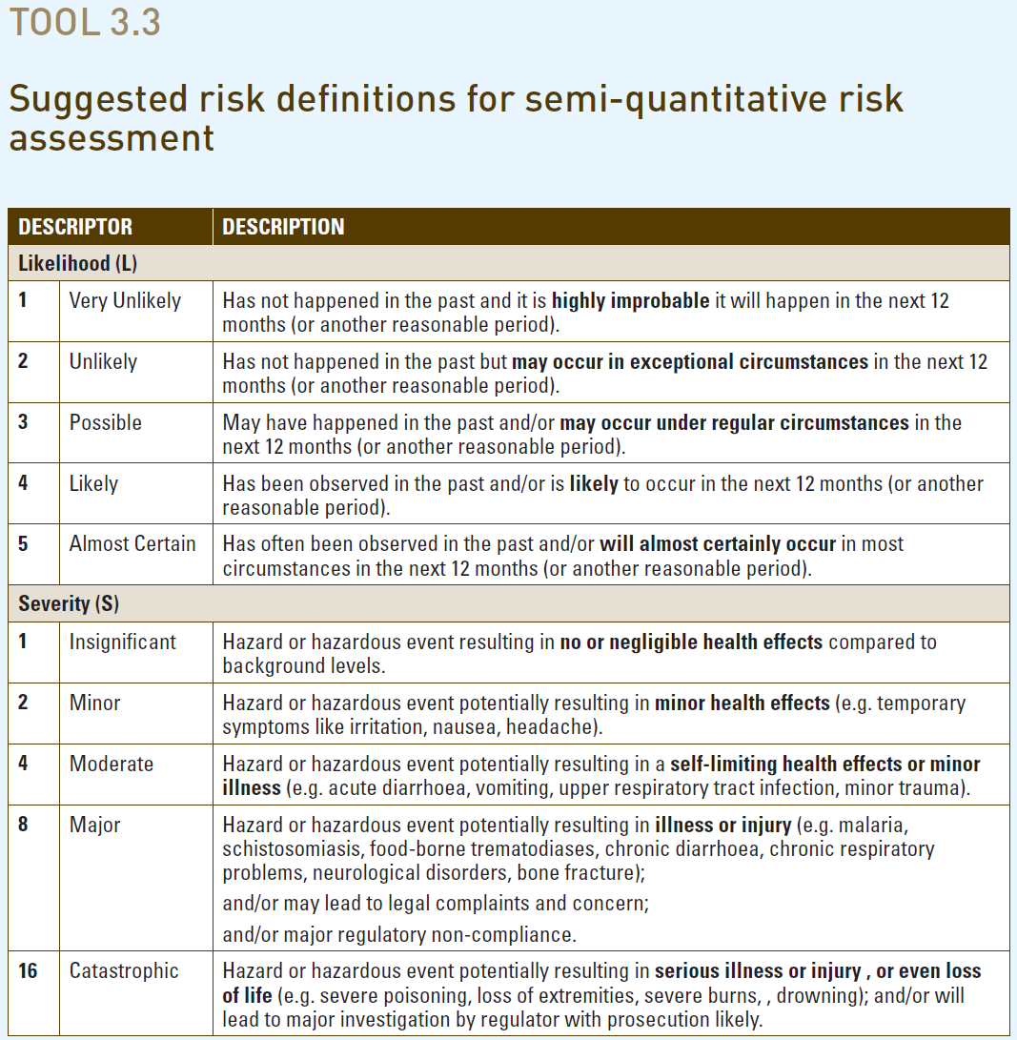 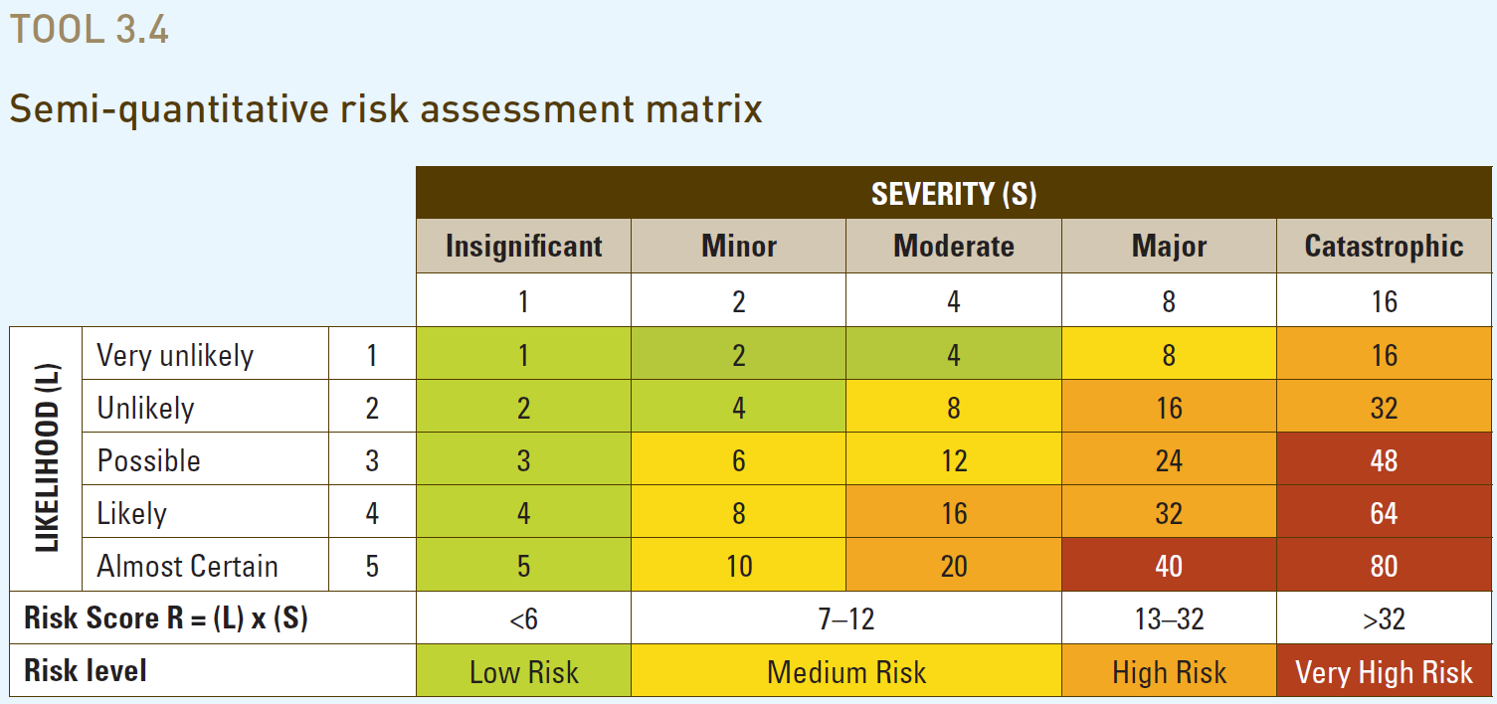

# The Potential Impact of Using the Pavitra Ganga Novel Technology in this System

# 

In this box explain what the impact would be on the biological risks, if the Pavitra Ganga novel technology is used in this system:

# Worksheet 3: Module 4 (simplified)

**Introduction:** In Module 4 an incremental improvement plan is developed. The options considered in this plan need to control the risks identified in Module 3.

**Task:** For the highest risk identified (column D4 of the hazard/risk table you have prepared before) consider options to control the identified risks (2-3 options). Use the table below for completing this exercise. (🡪 see Examples on pages 64-67 of the SSP Manual and the Newtown example on page 112).

**This should take you approximately 30 minutes**

## Table: Proposed control measures (simplified version)

| **Hazardous event (as per**  **Col B1 in previous activity): ..................................................................................................................................................................** | |
| --- | --- |
| **Option of new or modified control measure for this hazardous event** | **What is the likely effectiveness of this control measure option in reducing of risk of the hazardous event?** |
|  |  |
|  |  |
|  |  |

# Worksheet 4: Module 5 (simplified)

**Introduction:** The development of an operational and verification monitoring plan is at the core of Module 5. Based on these plans, the functionality of control measures can be monitored and the performance of the system is verified.

**Task1:** Complete the operational monitoring plan for a control measure of your choice from the table developed under worksheet activity 3 (🡪 see Example 5.1 on page 81 of the SSP Manual and the Newtown example Table 5.2 on page 116). Suggested sequence: 1) Write the name of the control measure of concern; 2) decide what will be monitored (Cell “What is monitored”); 3) complete the information related to the operational indicator, including the operational limit; and 4) then work on your response (= corrective action to be taken if the indicator is above/below the set operational limit/threshold).

**This should take you about 20 minutes**

## Table: Operational monitoring plan (simplified version)

|  |  |  |  |
| --- | --- | --- | --- |
| **Control measure of concern:** …………………………………………..…………………………………………………. | | | |
| **1.) Operational monitoring** | | **2.) Response** (if the indicator is above/below the set operational limit/threshold 🡪 case of failure) | |
| **What is monitored** (operational indicator): |  | **What corrective action is to be taken** |  |
| **Where it is monitored** |  |
| **Who monitors it** |  | **Who takes the action** |  |
| **Operational limit** (🡪 monitoring threshold) |  | **Who needs to be informed** |  |

# Worksheet 5: Module 5 (continued)

**Task2:** Define 1-2 verification monitoring parameters for your SSP system (point of the system of your choice) that may be useful to verify the overall system performance. For this purpose, use the simplified verification monitoring plan table below (🡪 see SSP Manual page 72, Guidance Note 5.3 on page 75 and Examples 5.2 and 5.3 on pages 82-83).

**This should take you about 10 minutes**

## Table: Verification monitoring plan (simplified version)

|  |  |  |  |  |
| --- | --- | --- | --- | --- |
| **Sanitation step** | **What is to be monitored** | **Verification limit/threshold** | **Frequency** | **Who does the monitoring** |
|  |  |  |  |  |
|  |  |  |  |  |